Admission Policy

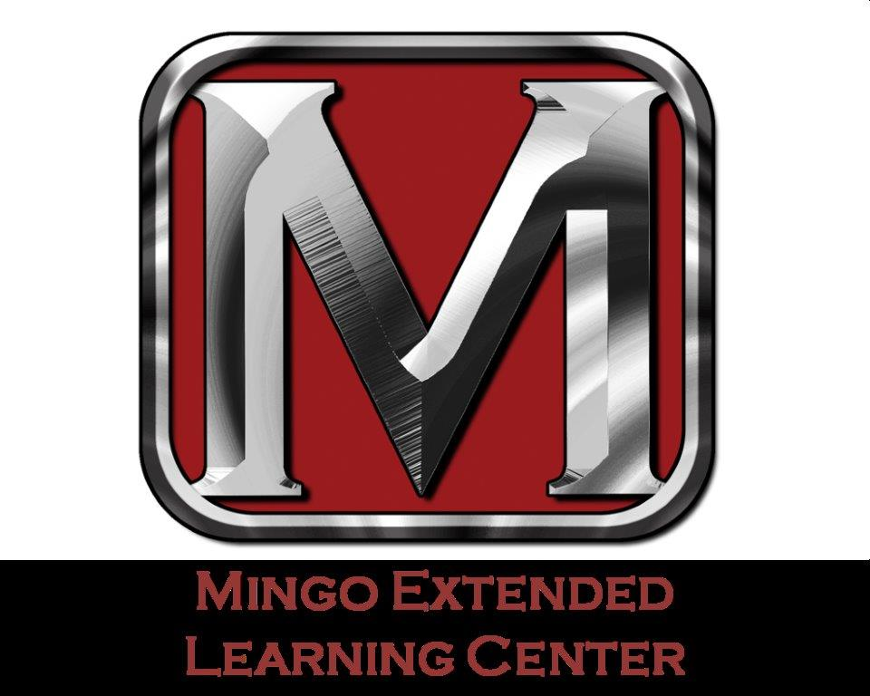

2024-2025

The Admissions Policy has been established to define the enrollment requirements for individuals planning to enroll at Mingo Extended Learning Center (MELC) as a student. The School must adhere to the U.S. Department of Education, Council on Occupational Education, and the State Agencies which govern the program.

**Discrimination**

As required by federal laws and regulations Mingo Extended Learning Center is open to all students and does not discriminate on the basis of race, color, religion, age, sex, creed, national origin, ethnicity, genetic orientation, sexual orientation, social status, disability or marital status.

If you feel you have been discriminated against based upon any of these reasons you may file a complaint by contacting:

**Mark Dean, CTE Administrator**

**Mingo Extended Learning Center**

**165 bulldog boulevard**

**Delbarton, WV 25670**

**304-475-3347-12**

**Also,**

**Dr. Johnny Branch, Asst. Superintendent**

**Mingo County Board of Education**

**110 Cinderella Rd.**

**Williamson, WV 25661**

**304-235-3333**

**General Admission Requirements**

To be eligible for admission, an applicant must be able to read, write, and understand English. Additionally, students must meet the following requirements.

* Complete an MELC Application for Admission
* Submit the proof of age, diploma and employability. Applicant must be at least 18 years of age.
* If primary language is not English potential applicants must take the TOEFL exam and score at least 80% to demonstrate English proficiency.
* Provide a valid driver’s license, state ID with photo, or valid passport.
* Student has verifiable Social Security Number.
* Students must also be able to provide proof of appropriate educational requirement such as:

1) Copy of high school diploma, or

2) Copy of high school transcript showing graduation date.

3) Copy of GED/TASC certificate

4) Have a recognized equivalent of High School Diploma such as a home-schooled certificate by the state where the student resided during home school. The student must have completed homeschooling at the secondary level as defined by state law. Due to the passage of Consolidated Appropriations Act of 2012, students who do not have a high school diploma or equivalent and did not complete secondary school in a home-school setting can no longer gain eligibility for Title IV, HEA funds by passing an “ability-to-benefit” test.

(Note: The high school diploma or transcript requirement can also be from a foreign school if it is equivalent to a US high school diploma; Documentation of proof of completion of secondary education from a foreign country must be officially translated into English and officially certified as the equivalent of high school completion in the United States.)

* Pay the required Registration Fee. (For the LPN program this is uniform, drug screen, and background check fees, for the Medical Office program this is $100 to hold the seat until classes begin.)
* A drug screen is required for all applicants of MELC programs and the cost is the applicant’s responsibility. The results are to be sent to MELC.
* A federal and state background check must be completed and the cost is applicant’s responsibility and the results are to be sent to MELC. Form Attached
* Agree to complete 25 hours of community service.

Mingo Extended Learning Center does not accept Ability to Benefit (ATB) students and does not offer a Comprehensive Transition Postsecondary Program.

**Transfer Students**

Enrollment is available for students wishing to transfer to Mingo Extended Learning Center after they have withdrawn from other schools both in and out of state. Mingo Extended Learning Center does not recruit students already attending or admitted to another school offering similar programs of study. All requests for exemption or credit for prior education must be submitted prior to the starting of training. All new students may request exemption from a course(s) based on post-secondary education or training. Transcripts from national or regionally accredited colleges and universities must be submitted for credit. Credit may be given for related courses taken within the last 10 years with an earned grade of “C” (in the practical nursing program a score of 80% is required) or above. Transfer of credit will be limited to enrollment at the School and official transcript must be given to the school prior to starting class. Credit is limited to no more than 50% of the total School program and certain classes may not be eligible for credit.

**Additional Admission for Licensed Practical Nursing Students**

1. Applicant must take the designated pre-admission test. Scores at or above the 55th percentile range composite on the examination ( waived during COVID-19 pandemic) and achieve a score of 50 or greater on the interview rubric. Scores shall be prioritized from highest to lowest to fill the quota for enrollment.
2. Applicants must take the TABE test achieving a score of 11th grade level. Applicants with scores below an 11th grade level will be offered additional education classes to help increase scores.
3. Prior to admission the prospective student is given a letter of intent, an interview with a school official and is given a pre-enrollment questionnaire packet, which they are required to read, understand and sign. The interview will elaborate on course description, the career opportunities and the physical demands of the job, the school and State Board requirements.
4. Upon admission to the LPN program the student will be required to attend a day of orientation outlining expectations of program. On the day of orientation students are required to pay for two uniforms at the cost of $100.00, background check costing $63.00, and drug screen costing $45.00 the total cost on the day of orientation will be $208.00 which is the responsibility of the student.
5. An explanation on attendance and academic requirement will be given to the prospective student and how those requirements can affect the student’s satisfactory performance requirements. The prospective student will be informed that attendance hours may be withheld for non-payment of tuition.
6. Once accepted into the program, applicants must have completed a physical exam by a physician or nurse practitioner. The physical examination should include a PPD (if PPD is positive, a chest x-ray is required), serology, complete blood culture, rubella titer, urinalysis, tetanus booster, and hepatitis B vaccine (if applicant has already received hepatitis B vaccine, a hepatitis B antibody titer must be done). If on medication of any kind, the applicant must list the medications on the examination form (this includes both prescription and over the counter drugs). A pre-admission dental exam is also required, and any dental repairs should be done prior to the start of classes.
7. Students are required to attend graduation for the current class. Additionally, students are required to attend a three-week refresher math course and study skills workshop and complete a Medical Terminology and Human Anatomy Terminology course if not taken previously, prior to the first day of school. If an applicant has already had a medical terminology class and can produce a transcript with a letter grade of at least “B”, he/she will not have to repeat this class. However, the math class and study skills workshop are mandatory for all applicants. All students must pass the math and medical terminology and human anatomy terminology finals with an 80% average before school begins.
8. Pre-requisite for the program is proof of a computer literacy class, medical terminology class, with a grade of 80% or better and a CPR/First Aide class and complete OSHA Safety Courses certificates.
9. Applicant must be in good physical, mental and dental health as verified by a licensed health care professional (physician, advanced practice nurse, dentist). Appropriate proof must be in the applicant’s file. Your health record must indicate that you are physically and mentally able to meet the requirement of the Practical Nursing program. If the applicant has a prior medical condition that can hinder the students learning process they must disclose this information prior to admission, any information that is not divulged is automatic disqualification for the LPN Program.
10. Applicant must have on file in the Nursing Office a minimum of three references from any past employers, clergy, counselors, teachers or personal friends who have known the applicant at least three years. NO RELATIVES may submit references. If the applicant has been employed in any area of health care, a reference from each employer must be submitted to the Nursing Office.
11. Applicant must have a personal interview with the admissions Committee. The applicant will be rated by each interviewer on appropriate dress, grooming, effectiveness of oral and written expression, overall attitude and manner and ability to follow instructions. A score of 50 or above on the interview rubric is required.
12. Prior to admission, a secured drug screen is required. The cost of the drug screen is the applicant’s responsibility. The results of the drug screen must be sent directly to the coordinator of the Mingo Extended Learning Center School of Practical Nursing. The presence of any illegal drug or prescription drug for which the applicant has no valid prescription will be grounds for immediate removal from the admissions process. Refusal to submit to a drug screen will be grounds for removal from the admissions process.
13. Prior to admission, a criminal background check must be completed. The results of the background check will be sent directly to the school. Each applicant will be fingerprinted on cards provided by the State Police. The cost of the background check is the applicant’s responsibility. The WV State Board of Examiners for Licensed Practical Nurse reserves the right to refuse to admit applicants to the licensure examination that have been convicted of a felony, are habitually intemperate, addicted to the use of drugs or is mentally incompetent, or who is guilty of professional misconduct including conviction of a misdemeanor with substantial relationship to the practice of nursing. Anyone who has a criminal conviction should contact the WV State Board of Examiners to discuss the potential impact of a criminal conviction on the application and licensure process as a practical nurse. Therefore, the Mingo Extended Learning Center School of Practical Nursing shall not consider applicants who, by reason of the above, would not be admitted for the NCLEX-P.N. examination.
14. All deadline dates must be met.

**To receive Federal Student Aid, you will need to:**

1. Qualify to obtain a college or career school education, either by having a high school diploma or High School Equivalency/GED/TASC certificate, or by completing a high school education in a home school setting approved under state law.
2. Be enrolled or accepted for enrollment as a ***regular student*** in an eligible licensure or certificate program.
3. Be registered with Selective Service, if you are a male (you must register between the ages of 18 and 25).

Men exempted from the requirement to register include;

* + Males currently in the armed services and on active duty (this exception does not apply to members of the Reserve and National Guard who are not on active duty);
  + Males who are not yet 18 at the time that they complete their application (an update is not required during the year, even if a student turns 18 after completing the application);
  + Males born before 1960;
  + Citizens of the Republic of Palau, the Republic of the Marshall Islands, or the Federated States of Micronesia;
  + Noncitizens that first entered the U.S. as lawful non-immigrants on a valid visa and remained in the U.S. on the terms of that visa until after they turned 26.

1. Have a valid Social Security number unless you are from the Republic of the Marshall Islands, Federated States of Micronesia, or the Republic of Palau.
2. Completed a FAFSA and the school must have a current ISIR to start the initial eligibility process.
3. Sign certifying statements on the ***FAFSA*** stating that:

* you are not in **default** on a **federal student loan**
* do not owe a refund on a **federal *grant***
* Sign the required statement that you will use federal student aid only for educational purposes

1. Maintain ***satisfactory academic progress (SAP)*** while you are attending college or a career school.
2. The Pell Grant program does not require half time enrollment, but the student enrollment status does affect the amount of Pell a student may receive. A student may receive Pell for a total of 12 payment periods or 600%. Once the student has reached this limit, no further Pell may be received.

**Note**: In order to be eligible for Title IV, HEA funding, you must be able to benefit with the reasonable accommodations

**Financial Arrangements:**

Students may not be accepted for enrollment if they cannot prove credit worthiness. Please see “Method and Terms of Payment”.

The student must make financial arrangements with the Financial Aid Office in regards to FAFSA application, scholarships and/or cash payment plan prior to enrolling.

Prior to admission the prospective student is given an enrollment agreement form, an interview with a school official and is given a pre-enrollment questionnaire packet, which they are required to read, understand and sign. The interview will elaborate on course description, the career opportunities and the physical demands of the job, the school and State Board requirements.

An explanation on attendance and academic requirement will be given to the prospective student and how those requirements can affect the student’s satisfactory performance requirements. The prospective student will be informed that attendance hours may be withheld for non-payment of tuition.

A staff member or instructor will give the prospective student a tour of the school facilities.

**Federal Financial Aid**

To be considered for Federal Financial Aid, a student must complete the Free Application for Federal Aid on line. The student and the parent (in the case of a dependent student) may sign the FAFSA on line by using a PIN number. Once the student completes the FAFSA, and it is processed by the government, the school will receive an ISIR which will contain the Estimated Family Contribution and let the student know if he/she is selected for verification.

**Verification**

Each year at least 30% of financial aid recipients are randomly selected for verification by the U.S. Department of Education. If a student is selected for federal verification, they will be asked to complete a Verification Worksheet (provided by the Office of Student Financial Planning) and must provide additional information before financial aid can be disbursed to the student account. This documentation may include but is not limited to federal income tax transcript and W-2 forms (student’s, spouse and/or parents/guardians), proof of untaxed income, housing allowances, etc.

Students will be notified in writing of all documents required to fulfill this federal requirement. If after review by the Office of Student Financial Planning, there are any changes to the Estimated Family Contribution and possibly the financial aid available, the student will be notified in writing.

**In addition, you must meet one of the following:**

1. Be a U.S. CITIZEN or U.S. NATIONAL

You are a U.S. citizen if you were born in the United States or certain U.S. territories, if you were born abroad to parents who are U.S. citizens, or if you have obtained citizenship status through naturalization. If you were born in American Samoa or Swains Island, then you are a U.S. national.

1. Have a GREEN CARD

You are eligible if you have a Form I-551, I-151, or I-551C, also known as a green card, showing you are a U.S. permanent resident.

1. Have an ARRIVAL-DEPARTURE RECORD

You’re Arrival-Departure Record (I-94) from U.S. Citizenship and Immigration Services must show one of the following:

* + Refugee
  + Asylum Granted
  + Cuban-Haitian Entrant (Status Pending)
  + Conditional Entrant (valid only if issued before April 1, 1980)
  + Parolee

1. Have BATTERED IMMIGRANT STATUS

You are designated as a **“battered immigrant-qualified alien”** if you are a victim of abuse by your citizen or permanent resident spouse, or you are the child of a person designated as such under the **Violence Against Women Act**.

1. Have a T-VISA

You are eligible if you have a T-visa or a parent with a T-1 visa.

**Incarcerated Applicants**

A student is considered to be incarcerated if she/he is serving a criminal sentence in a federal, state, or local penitentiary, prison, jail, reformatory, work farm, or similar correctional institution (whether it is operated by the government or a contractor). A student is not considered to be incarcerated if she/he is in a halfway house or home detention or is sentenced to serve only weekends. Our attendance policy specifies that all classed and practical studies are done at the school’s physical location; therefore, incarcerated students are not eligible for admissions.

**Conviction for possession or sale of illegal drugs**

* A Federal or state drug conviction can disqualify a student for FSA funds. The student self-certifies in applying for aid that he/she is eligible for by using the FAFSA. The School is not required to confirm this unless there is evidence of conflicting information.
* The chart below illustrates the period of ineligibility for FSA funds, depending on whether the conviction was for sale or possession and whether the student had previous offenses. (A conviction for the sale of drugs includes conviction for conspiring to sell drugs)

|  |  |  |
| --- | --- | --- |
|  | Possession of illegal drugs | Sale of illegal drug |
| 1st Offense | 1 year from date of conviction | 2 year from date of conviction |
| 2nd Offense | 2 year from date of conviction | Indefinite period |
| 3+ Offense | Indefinite period |  |

* If a student was convicted of both possessing and selling illegal drugs, and the periods of ineligibility are different the student will be ineligible for the longer period
* A student regains eligibility the day after the period of ineligible ends or when he/she successfully completes a qualified drug rehabilitation program. Further drug conviction will make him/her ineligible again.
* When a student regains eligibility during the award year, the institute may award Pell for the current payment period.
* A qualified drug rehabilitation program must include at least two unannounced drug tests and must satisfy at least one of the following requirements:
  + Be qualified to receive funds directly or indirectly from a federal, state or local government program.
  + Be qualified to receive payment directly or indirectly from a federally or state-licensed insurance company.
  + Be administered or recognized by federal, state or local government agency or court.
  + Be administered or recognized by a federally or state-licensed hospital, health clinic or medical doctor.

Upon receipt of all required documents and in good order, the prospective student is eligible to enroll in the school. When all admissions criteria and requirements are met, the prospective student is given the date of the next class. The prospective student is asked to bring their Student Permit Fee, if applicable, a color photo of them and is informed of the appropriate dress code. The first day of class will include financial aid and academic orientation, in which the students will sign their enrollment contract, student permit from and additional required paperwork.

**Students with Disabilities:**

Mingo Extended Learning Center complies with the Americans with Disabilities Act of 1990 and is wheelchair accessible. If enrolled under training with a government agency, institution district, and/or other entity, students must meet the admission requirements set out in the training agreement and/or applicable state licensing or certifications requirements. The facility is equipped with ramp access from the parking lot, extra wide hallways and doors, A.D.A. required door handles and a restroom to accommodate disabled students.

If you are interested in attending Mingo Extended Learning Center and need reasonable accommodations, you should schedule an appointment with the Administrator. At this meeting, we will discuss the nature of the reported disability and its impact on learning. We will also discuss the process of receiving reasonable accommodations at the Mingo Extended Learning Center, and the types of accommodations available.

Please bring copies of current documentation of a disability to this meeting. Documentation must be provided by a medical expert within the last three years and include:

* a diagnosis of the disability;
* how the diagnosis was determined (what tests were given and the results); and
* A clinical summary, which includes an assessment of how the disability will impact the individual in a college environment and what accommodations are recommended.

Upon completion of the initial meeting, a formal request for the accommodation must be submitted in writing to the school. The initial meeting, formal request, and response from the school must take place prior to the pre-enrollment process.

**Veterans Benefits/Other Funding Sources**

Selected programs of study at Mingo Extended Learning Center are approved by the veterans Commission for enrollment of those eligible to receive benefits under Section 3676, Chapters 30 or 32, Title 38. The determination for WVVC funds are made directly through the West Virginia Veteran’s Commission. Additional funding may be obtained for eligible candidates through many different programs including; Workforce West Virginia Unemployment Compensation Division, State of West Virginia Division of Rehabilitation Services, and Private Scholarship funds. The determinations for these funds are made through the respective organizations.

**CONTACT INFORMATION FOR ASSISTANCE IN OBTAINING**

**INSTITUTIONAL OR FINANCIAL AID INFORMATION**

Disclosure Requirement: Made available through appropriate publications, mailings, or electronic media

Each institution must make available to prospective and enrolled students’ information regarding how and where to contact individuals designated to assist enrolled or prospective students in obtaining the institutional or financial aid information required to be disclosed under HEA Sec. 485(a). This information is posted on Mingo Extended Learning Center’s website can be found in the student handbook/catalog. Paper copies are available upon request.

**Due to a National Pandemic TABE scores will be omitted until testing at the sites can resume.**

**Mingo Extended Learning Center**

**Institutional Contact Information**

**Administrator**

**Mark Dean**

[**dmdean@k12.wv.us**](mailto:dmdean@k12.wv.us)

**304-475-3347 Ext. 12**

**LPN Program Coordinator**

**Tammy Gilman**

**tammy.gilman@k12.wv.us**

**304-475-3347 Ext. 29**

**LPN Instructor**

**Connie Hager**

[**connie.hager@k12.wv.us**](mailto:connie.hager@k12.wv.us)

**304-475-3347 EXT. 39**

**Financial Aid Advisor/Counselor**

**Kristi Parsley-Adams**

[**kparsleyadams@k12.wv.us**](mailto:kparsleyadams@k12.wv.us)

**304-475-3347 Ext. 13**

**Inquiries may be sent to**

**Mingo Extended Learning Center**

**165 Bulldog Blvd**

**Delbarton, WV 25670.**

**Accreditation Agencies**

**West Virginia Department of Education**

**Office of Adult and Technical Education**

**Building 6 Room 221**

**1900 Kanawha Blvd. East**

**Charleston, WV 25305-0330**

**304-558-3119 phone**

**304-558-1055 fax**

**wvde.us**

**Council on Occupational Education**

**7840 Roswell Road**

**Building 300, Suite 325**

**Atlanta GA, 30350**

**770-396-3898 or 1-800-917-2081 phone**

**770-396-3790 fax**

[**www.council@org**](http://www.council@org)

**Pell Eligibility**

**United States Department of Education**

**Federal Student Aid Schools Channel**

**Attention: Philadelphia School Participation Team**

**Union Center Plaza**

**830 First Street, North East**

**Washington, DC 20202**

**Instructions for Applying for Background Check**

STATE and FEDERAL BACKGROUND CHECK Cost at Chapmanville: **$45.50** (may want to check to make sure it hasn’t changed). You will need a money order made out to Morpho Trust when you go, or you can use a debit card when making the appointment. Cost to mail federal hard card: **$18.00** (we will mail them all together, so bring this and the card to school after you go). If the cost is included on your program cost sheet, bring the receipt and you will be reimbursed. You will need another money order made out to FBI CJIS Division. If you do not have the money up front, see me and we will work something out. Toll free number for Morpho Trust is (855) 766-7746.

**Location:** *Quality Drug Testing, 8 Airport Rd., Chapmanville, WV 25508-9698, (304) 855 0058*

Must have photo ID when you go.

***Go to identogo.com to schedule an appointment for your background check.***

Click the ***“Make a New Appointment” – Start the appointment process*** button.

**Step 1: Your Program:**

* Type of background check – Select ***WV Hard Card***
* Add a service ***–*** Select ***WV Employer Record Check***
* Do you have a facility number? – Select ***No***
* Facility Name – Select ***Not listed***
* On the Services, WV Employer Record Check page, Click ***Continue***

**Step 2: Your details:**

* On the application form, complete your name and other required demographic information. For the following key (leave blank if not required):
  + Employer Name – ***Mingo Extended Learning Center***
  + Employer Address Line 1 – ***165 Bulldog Blvd.***
  + Employer City – ***Delbarton***
  + Employer Zip – ***25670***
  + Employer Country – ***United States***
  + Are you a US Citizen – ***Yes***
  + Click ***Continue*** – if site doesn’t advance, scroll to top to see if you missed filling out any information.

**Step 3: Your appointment:**

* + Select Location – ***Chapmanville***
  + Select Appointment Date and Time
  + After the last step I quit filling out the rest; but it should be fairly easy to follow.

**Step 4: Your review**

**Step 5: Your confirmation**